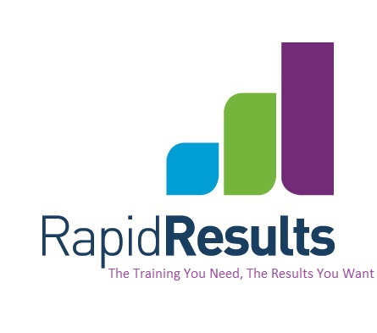

Debt Collection

Virtual Classroom via Zoom
The Training You Need: The Results You Want

Aim:
To improve knowledge and skill in providing win-win outcomes in all aspects of debt collection.

Delivery:
We will use the Zoom platform to deliver this.
- Limited numbers
- Breakout sessions for discussion & practice
- Fully interactive with participants & facilitator
- Reference material
- 3 months support

DATE: Wednesday February 21st
TIME: 9am – 4.30
COST: $540 + GST

Outline:
The course will cover the following:
Outbound calling: Skills to prepare for debt collection calls. Be in the right “head space”
Call Flow understanding: Direct the call and maintain control - minimise call time and number of contacts needed for resolution.
Establishing contact: Get through gatekeeper issues and debtor avoidance. Overcome resistance – change the perspective of the debtor to that of quick and willing cooperation.
Influencing techniques: Words and phrases to motivate positive action and get a firm resolution that the person is committed to follow through with.
Negotiation: Understand the value of negotiation, problem solving and increasing debtor motivation. Respond flexibly to the person’s unique circumstances while standing your ground in terms of company policy and debt resolution.
Options & Alternatives: Give additional options or alternatives that relate to the person’s situation – educate and support for a win-win outcome.
Gaining Commitment: ‘Closing’ techniques to get immediate and full settlement.



3/37 Wilkinson Rd P: (09) 447 1994
Auckland 1060 E: carolyn@rapidresults.co.nz
www.rapidresults.co.nz

